logo | Sardar Vallabhbhai patel institute of technology, vasad campus

Main login page
Auditorium Request form  Maintenance Request form  Purchase Request form  Car requestions form  Inventory Portal  As Per Your Design is ok | Select for 1) Auditorium portal  2) Maintenance department  3) Purchase department  4) Car requestions portal  5) Inventory Portal  Role Authority admin  Admin  Head  Maintance  Clerk  User id :  Password :  Forget password
Above fatche to admin panel for all chagnes

Admin Panel

logo | Sardar Vallabhbhai patel institute of technology, vasad campus
Upload logo option | Name edit,delete,save option add

Add in admin login for this role and back to main page button all pages

Manage departments and Heads

Sender email address for all notifications.

- Auditorium approval (First Page) only seen selected person

Requests in your lane

Auditorium approval desk

Add Button Auditoriums

Manage auditorium list ↗
- Maintenance approval desk

Requests in your lane.

Maintenance Approval Desk

Manage departments and Heads fetch from Auditorium approval Only role assign manually selection

- Purchase
- Stationary item
- Requests form in your lane for approval show
- Manually added items and quantity and auto calculation stock previous (show only admin user and role to purchase officer and clerk)
- Add Stationary item excel template and upload excel, download excel (using in purchase)
- Generated pdf for printout if required (after approval) and request item form pdf note approval to faculty name-head-principal
- Fetch department name and head email id in (Manage departments and Heads) Main page added
- Role Select option for Department Clerk-Head-Principal-Purchase officer-after seen stock clerk and issue martial tick and minus stock record
- Local purchase
- New Local Purchase entry by select Department in campus
- Requests form in your lane for approval show
- Role approval form head-principal-chairman (if Required) dynamic amount set for purchse officer Rs. 10000/- Up –
- Approval Role for head-principal- purchase officer- none-chairman (if 10000 up order) approval
- Gentrate approval in pdf with approval diagram after sign box for purchase officer – head- principal and chairman (if required)
- Cleaning item
- Requests form in your lane for approval show
- Manually added items and quantity and auto calculation stock previous (show only admin user and role to purchase officer and clerk)
- Add cleaning item excel template and upload excel, download excel (using in purchase)
- Generated pdf for printout if required (after approval) and request item form pdf note approval to faculty name-head-principal
- Fetch department name and head email id in (Manage departments and Heads) Main page added
- Role Select option for Department Clerk-Head-Principal-Purchase officer-after seen stock clerk and issue martial tick and minus stock record
- Car requestions form
Requests form in your lane for approval show
Approval role assign to head-admin officer-principal-non

5) Inventory Role to assign clerk-lab technician-head-principal-admin-chairman seen manually
Department Select option
Data entry format: year wise new purchase adds manually
Sr. No. | Item |  | Ground floor (Manually add Colum)  Name Office, Lab Manually added  Edit option save | First floor (Manually add Colum) Name Office, Lab Manually added Edit option save | Second floor (Manually add Colum) Name Office, Lab Manually added Edit option save | Third floor ((Manually add Colum) Name Office, Lab Manually added Edit option save | Total | Remarks | Transform to other department (if require) manually entry | Use / non use itme selection
 |  | Option furniture,  Electrical, | Edit option save
 |  |  | Edit option save
 |  |  | Edit option save
 |  |  | Edit option save
 |  |  | Edit option save

All items generate Department name wise total option

1. MAIN LOGIN PAGE
Header
[SVIT LOGO]
Sardar Vallabhbhai Patel Institute of Technology
Vasad Campus
Campus Administration Portal
Login Form
Field | Input
User ID | Email / Employee ID
Password | ********
Role | Automatically identified / optional selection
Remember Me | ☑
Login | 🔐 Login
Forgot Password | Click here
Login Roles
- Admin
- Principal
- Head
- Purchase Officer
- Maintenance Officer
- Clerk
- Lab Technician
- Authorized User
- Chairman
Main Page Buttons
After the login section, the main portal can display:
① Auditorium Request
② Maintenance Request
③ Purchase Request
④ Car Requisition
⑤ Inventory Portal
A user can see only the portal for which permission has been assigned.

2. COMMON DASHBOARD
After successful login:
Header
SVIT Logo | Sardar Vallabhbhai Patel Institute of Technology, Vasad Campus
Right side:
🔔 Notifications | 👤 User Name | Role | Logout

Dashboard Cards
For Admin
Card | Information
🏛 Auditorium | Total / Pending
🔧 Maintenance | Total / Pending
🛒 Purchase | Total / Pending
🚗 Car Requisition | Total / Pending
📦 Inventory | Total Items
👥 Users | Active Users
🏢 Departments | Total Departments
⚠ Stock | Low Stock Items
Quick Actions

  - New Auditorium Request

  - New Maintenance Request

  - New Purchase Request

  - New Car Requisition

  - Inventory Entry
- Manage Users
- Manage Departments
- Pending Approvals
Common Request Table
Request No. | Date | Department | Request Type | Requested By | Current Authority | Status
AUD-0001 | 28-08-26 | CSE | Auditorium | Faculty | Head | Pending
PUR-0021 | 28-08-26 | Mechanical | Stationery | Clerk | Purchase Officer | Pending
Status:
🟡 Pending
🟢 Approved
🔴 Rejected
🔵 In Process
⚫ Completed

3. PORTAL 1 — AUDITORIUM REQUEST
User Page
New Auditorium Request
Fields:
- Request Number — Auto
- Department
- Faculty / Employee Name
- Email
- Mobile
- Event Name
- Event Type
- Date
- Start Time
- End Time
- Expected Participants
- Auditorium
- Required Facilities
  - Projector
  - Sound System
  - AC
  - Microphone
  - Stage
  - Seating
  - Other
- Special Requirement
- Attachment
- Submit
Auditorium Master
Admin:
Manage Auditoriums
Auditorium | Capacity | Location | Facilities | Status | Edit
Aero Auditorium | 250 | 2nd Floor | Projector, Sound | Active | Edit
EDC Hall | 150 | 1st Floor | Projector | Active | Edit
Buttons:
+ Add Auditorium
Edit | Delete | Active/Inactive

Auditorium Approval Desk
Requests in Your Lane
Only requests assigned to the logged-in authority should appear.
Request | Department | Date | Time | Applicant | Status | Action
AUD-001 | CSE | 05-09-26 | 10-1 | Mr. ABC | Pending | View
Approval Screen
- Request Details
- Previous Approvals
- Comments
- Approve
- Reject
- Send Back
- Forward
- Digital approval/signature

4. PORTAL 2 — MAINTENANCE
New Maintenance Request
Request Form
- Request No.
- Department
- Location / Building
- Floor
- Room No.
- Requester
- Category
  - Electrical
  - Plumbing
  - Civil
  - AC
  - Furniture
  - Computer/IT
  - Other
- Problem Description
- Priority
  - Normal
  - Urgent
  - Emergency
- Photo/Attachment
- Required Date
- Submit

Maintenance Approval Desk
Requests in Your Lane
The system automatically fetches:
Manage Departments & Heads → Department → Head → Email
No need to enter Head information repeatedly.
Maintenance Workflow
Employee
↓
Department Head
↓
Maintenance Officer
↓
Maintenance Clerk / Technician
↓
Work Completed
↓
Requester Confirmation
↓
Close Request
Maintenance Status
- New
- Head Approval Pending
- Maintenance Pending
- Assigned
- In Progress
- Completed
- Verified
- Closed
- Rejected

5. PORTAL 3 — PURCHASE
Purchase should have three independent sections:
A. Stationery
B. Local Purchase
C. Cleaning Items

5A. STATIONERY
Stationery Request
Item | Required Qty | Available Stock | Issue Qty
A4 Paper | 10 | 50 | 10
Pen | 100 | 250 | 100
Important Rule
Available Stock information is visible only to:
- Admin
- Purchase Officer
- Stock Clerk
Other users should see only the request information.

Stationery Master
Excel Upload
Admin/Purchase Officer can:
- Download Excel Template
- Upload Excel
- Validate Excel
- Import Items
- Update Items
- Export Excel
Example:
Item Code | Item Name | Category | Unit | Minimum Stock | Opening Stock
STA001 | A4 Paper | Stationery | Ream | 10 | 100
STA002 | Ball Pen | Stationery | Box | 5 | 50

Stationery Approval
Department Clerk
↓
Department Head
↓
Purchase Officer
↓
Stock Clerk
↓
Issue Material
↓
Stock Automatically Deducted
Example:
Previous Stock = 100
Issued = 20
New Stock = 80
The system should automatically create a stock transaction.

PDF
After approval:
Generate PDF
PDF should contain:
- SVIT Logo
- Institute Name
- Request No.
- Date
- Department
- Requested By
- Items
- Quantity
- Approval history
- Approval/signature boxes
Signature section:
Requested By | Department Head | Principal/Purchase Authority

5B. LOCAL PURCHASE
New Local Purchase
Select:
Department
Then:
- Purchase Request No.
- Date
- Department
- Requested By
- Item
- Description
- Quantity
- Estimated Rate
- Estimated Amount
- Vendor, if known
- Quotation attachment
- Justification
- Remarks
Automatic Calculation
Quantity × Rate = Amount
Subtotal + Other Charges = Total

LOCAL PURCHASE APPROVAL ENGINE
This should be dynamic.
Admin can configure:
Example
Up to ₹10,000
Department Head → Purchase Officer
Above ₹10,000
Department Head → Principal → Chairman
The amount threshold should not be hard-coded.
Admin can change:
₹10,000 → ₹25,000
without changing the application code.

Local Purchase Approval Diagram
Example:
REQUESTER
↓
DEPARTMENT HEAD
↓
PURCHASE OFFICER
↓
PRINCIPAL
↓
CHAIRMAN
↓
APPROVED
Only required authorities should appear.
If Chairman approval is not required:
REQUESTER
↓
HEAD
↓
PURCHASE OFFICER
↓
APPROVED

5C. CLEANING ITEMS
Same basic structure as Stationery.
Features
- Cleaning Item Master
- Excel Upload
- Excel Download
- Stock Management
- Department Request
- Quantity
- Previous Stock
- Issue Quantity
- Automatic Stock Deduction
- Approval
- PDF
- Email Notification
Cleaning Item Example
Code | Item | Unit | Minimum Stock | Current Stock
CL001 | Floor Cleaner | Bottle | 10 | 25
CL002 | Phenyl | Litre | 20 | 50
CL003 | Broom | Nos. | 10 | 35

6. PORTAL 4 — CAR REQUISITION
New Car Requisition
Fields:
- Requisition No.
- Department
- Requester
- Date
- Required Date
- Reporting Time
- Return Time
- Destination
- Purpose
- Number of Persons
- Vehicle Type
- Driver Required
- Special Instructions
- Attachment
Approval Role
Admin should be able to configure:
- Head
- Admin Officer
- Principal
- None
- Other Authority
Workflow
CAR REQUEST
↓
DEPARTMENT HEAD
↓
ADMIN OFFICER
↓
PRINCIPAL
↓
CAR/DRIVER ASSIGNMENT
↓
TRIP COMPLETED
↓
CLOSE

Car Request Dashboard
Req. No. | Department | Date | Destination | Persons | Status
CAR001 | Civil | 02-09-26 | Ahmedabad | 8 | Approved
Admin can assign:
- Vehicle
- Driver
- Departure Time
- Return Time

7. PORTAL 5 — INVENTORY
This will be a more comprehensive asset/inventory module.
Inventory User Roles
Admin can assign:
- Clerk
- Lab Technician
- Head
- Principal
- Chairman
- Inventory Officer

Department Selection
First select:
Department
Then:
- Academic Year
- Inventory Year
- Category
Categories:
- Furniture
- Electrical
- Computer/IT
- Laboratory
- Other

INVENTORY DATA ENTRY
Main Table
Sr. No. | Item | Ground Floor | First Floor | Second Floor | Third Floor | Total | Remarks
1 | Table | 10 | 5 | 8 | 2 | 25 | Good
2 | Chair | 20 | 15 | 10 | 5 | 50 | Good
3 | Computer | 0 | 20 | 25 | 10 | 55 | Working
But each floor should internally store:
Office / Lab + Room + Quantity
Example:
First Floor
├── Office
│ └── 5
└── Computer Lab-1
└── 20
This will make future reporting much easier.

Inventory Actions
Each item should have:
Edit | Save | Transfer | Use/Non-use | View History
Transfer
Example:
Computer Lab – CSE
↓
Transfer
↓
Computer Lab – IT
The system records:
- From Department
- To Department
- Item
- Quantity
- Date
- Reason
- Authorized By

8. INVENTORY REPORTS
Admin should have:
Department-wise
CSE
Furniture 125
Electrical 45
Computer 85
Other 20
--------------------
Total 275
Floor-wise
- Ground Floor Total
- First Floor Total
- Second Floor Total
- Third Floor Total
Category-wise
- Furniture
- Electrical
- Computer
- Laboratory
- Other
Status-wise
- In Use
- Not in Use
- Damaged
- Under Repair
- Transferred
Reports
- PDF
- Excel
- Print
- Year-wise Report
- Department-wise Report
- Item-wise Report

9. ADMIN PANEL
This is the master control center.
Admin Dashboard
Administration Menu
Dashboard

MASTER SETTINGS
├── Institute Profile
├── Logo
├── Departments
├── Heads
├── Users
├── Roles
├── Permissions
└── Email Settings

AUDITORIUM
├── Auditoriums
├── Approval Rules
└── Requests

MAINTENANCE
├── Departments
├── Categories
├── Approval Rules
└── Requests

PURCHASE
├── Stationery
├── Local Purchase
├── Cleaning Items
├── Stock
└── Approval Rules

CAR
├── Vehicles
├── Drivers
└── Approval Rules

INVENTORY
├── Items
├── Departments
├── Transfers
└── Reports

REPORTS
├── Request Reports
├── Approval Reports
├── Purchase Reports
├── Stock Reports
└── Inventory Reports

SYSTEM
├── Email
├── Notifications
├── Audit Log
├── Backup
└── Settings

10. MANAGE DEPARTMENTS & HEADS
Department Master
Department | Code | Head | Head Email | Status | Action
Computer Engineering | CE | Dr. ABC | head@svit... | Active | Edit
Mechanical | ME | Dr. XYZ | head@svit... | Active | Edit
Admin can:
Add | Edit | Delete | Activate/Deactivate
When a department is selected anywhere in the portal, the system automatically fetches the corresponding Head.

11. USER MANAGEMENT
Add User
Fields:
- Employee ID
- Name
- Email
- Mobile
- Department
- Designation
- Role
- Username
- Password / Reset Password
- Status
Role Assignment
Example:
Mr. A
Department: Computer Engineering
Role: Clerk
Permissions:
✓ Stationery Request
✓ Cleaning Request
✓ Inventory View
✗ Stock Management
✗ Admin Panel

12. ROLE & PERMISSION SYSTEM
Instead of giving fixed permissions, use a permission matrix.
Module | Admin | Head | Clerk | Purchase | Maintenance | Principal
Auditorium | ✓ | ✓ | Request | — | — | ✓
Maintenance | ✓ | ✓ | Request | — | ✓ | ✓
Purchase | ✓ | Approve | Request | ✓ | — | ✓
Car | ✓ | Approve | Request | — | — | ✓
Inventory | ✓ | View | Entry | Stock | — | View
Users | ✓ | — | — | — | — | —
Settings | ✓ | — | — | — | — | —
Admin can modify permissions.

13. APPROVAL ENGINE
This is one of the most important parts of the system.
Instead of programming every approval workflow separately, create a common:
Approval Workflow Engine
Request
↓
Find Department
↓
Find Applicable Workflow
↓
Find Amount / Request Type
↓
Find Required Role
↓
Create Approval Task
↓
Send Notification
↓
Approver Action
↓
Next Approval
↓
Final Approval
↓
Generate PDF
↓
Complete
Approval Actions
- Approve
- Reject
- Send Back
- Forward
- Return for Correction
- Add Comment
Every action should be recorded.

14. NOTIFICATION SYSTEM
Admin setting:
Sender Email Address
Example:
admin@svitvasad.ac.in
System sends notifications for:
- New Request
- Approval Pending
- Approved
- Rejected
- Sent Back
- Purchase Approved
- Material Issued
- Maintenance Completed
- Car Approved
- Inventory Transfer
Notification
Subject:
Purchase Request PUR-0025 Awaiting Your Approval
Email contains:
- Requester
- Department
- Amount
- Request details
- Approval button
- Login button

15. DATABASE STRUCTURE
I recommend using PostgreSQL/Supabase for this system because the portal has many interconnected modules, approval workflows and audit records.
Core Tables
1. users
users
-----
id PK
employee_id
name
email
mobile
department_id FK
designation
password_hash
status
created_at
updated_at
2. roles
roles
-----
id PK
role_name
description
status
3. permissions
permissions
-----------
id PK
module
action
description
4. user_roles
user_roles
----------
id PK
user_id FK
role_id FK
5. role_permissions
role_permissions
----------------
id PK
role_id FK
permission_id FK

16. ORGANIZATION TABLES
departments
departments
-----------
id PK
department_code
department_name
head_user_id FK
head_email
status
designations
designations
------------
id PK
designation_name
status

17. AUDITORIUM TABLES
auditoriums
auditoriums
-----------
id PK
name
location
capacity
facilities
status
auditorium_requests
auditorium_requests
-------------------
id PK
request_no
department_id FK
requested_by FK
event_name
event_type
request_date
start_time
end_time
auditorium_id FK
participants
description
status
created_at

18. MAINTENANCE TABLES
maintenance_requests
maintenance_requests
--------------------
id PK
request_no
department_id FK
requested_by FK
location
floor
room_no
category
priority
description
attachment
status
created_at
maintenance_assignments
maintenance_assignments
-----------------------
id PK
request_id FK
assigned_to FK
assigned_date
completion_date
remarks
status

19. PURCHASE TABLES
purchase_items
purchase_items
--------------
id PK
item_code
item_name
category
unit
minimum_stock
current_stock
status
purchase_requests
purchase_requests
-----------------
id PK
request_no
request_type
department_id FK
requested_by FK
total_amount
justification
status
created_at
purchase_request_items
purchase_request_items
---------------------
id PK
request_id FK
item_id FK
quantity
rate
amount

20. STOCK TABLE
Do not rely only on current_stock.
Create a proper transaction table.
stock_transactions
stock_transactions
------------------
id PK
item_id FK
department_id FK
transaction_type
quantity
previous_stock
new_stock
reference_type
reference_id
issued_by FK
transaction_date
remarks
Transaction types:
PURCHASE
OPENING
ISSUE
RETURN
TRANSFER_IN
TRANSFER_OUT
ADJUSTMENT
DAMAGE
This provides a complete stock history.

21. LOCAL PURCHASE APPROVAL TABLE
approval_workflows
approval_workflows
------------------
id PK
module
request_type
min_amount
max_amount
status
approval_workflow_steps
approval_workflow_steps
-----------------------
id PK
workflow_id FK
step_no
role_id FK
required
Example:
Workflow | Amount | Step | Role
LP-1 | 0–10,000 | 1 | Head
LP-1 | 0–10,000 | 2 | Purchase Officer
LP-2 | 10,001+ | 1 | Head
LP-2 | 10,001+ | 2 | Purchase Officer
LP-2 | 10,001+ | 3 | Principal
LP-2 | 10,001+ | 4 | Chairman
This makes the approval process fully configurable.

22. APPROVAL TRANSACTION TABLE
approvals
approvals
---------
id PK
request_type
request_id
workflow_id FK
step_no
approver_user_id FK
approver_role_id FK
action
comments
approved_at
ip_address
Actions:
PENDING
APPROVED
REJECTED
SENT_BACK
FORWARDED

23. CAR TABLES
vehicles
vehicles
--------
id PK
vehicle_no
vehicle_type
capacity
driver_id
status
drivers
drivers
-------
id PK
name
mobile
license_no
status
car_requests
car_requests
------------
id PK
request_no
department_id FK
requested_by FK
travel_date
reporting_time
return_time
destination
purpose
persons
vehicle_id FK
driver_id FK
status

24. INVENTORY TABLES
inventory_items
inventory_items
---------------
id PK
item_code
item_name
category
department_id FK
year
status
remarks
inventory_locations
inventory_locations
-------------------
id PK
department_id FK
floor
building
room_no
location_type
location_name
inventory_assets
inventory_assets
----------------
id PK
item_id FK
location_id FK
quantity
condition
use_status
remarks
inventory_transfers
inventory_transfers
-------------------
id PK
item_id FK
from_department_id
to_department_id
from_location_id
to_location_id
quantity
transfer_date
authorized_by
remarks

25. COMMON ATTACHMENT TABLE
One common attachment system can be used instead of separate attachment fields everywhere.
attachments
attachments
-----------
id PK
module
reference_id
file_name
file_path
file_type
uploaded_by
uploaded_at
Supports:
- PDF
- JPG
- PNG
- Excel
- Word

26. NOTIFICATION TABLE
notifications
notifications
-------------
id PK
user_id FK
title
message
module
reference_id
is_read
created_at

27. AUDIT LOG
Very important for an institutional portal.
audit_logs
audit_logs
----------
id PK
user_id FK
module
action
reference_id
old_data
new_data
ip_address
created_at
This allows Admin to see:
Who changed what, when, and from which account.

28. SYSTEM SETTINGS
system_settings
system_settings
---------------
id PK
setting_key
setting_value
description
updated_by
updated_at
Examples:
INSTITUTE_NAME
INSTITUTE_LOGO
SENDER_EMAIL
PURCHASE_LIMIT
CURRENCY
TIMEZONE
EMAIL_ENABLED

29. DATABASE RELATIONSHIP
The overall relationship should look like:
┌──────────────┐
│ USERS │
└──────┬───────┘
│
┌──────▼───────┐
│ ROLES │
└──────┬───────┘
│
┌──────▼─────────┐
│ PERMISSIONS │
└────────────────┘

┌─────────────┐
│ DEPARTMENTS │
└──────┬──────┘
│
├───────────────┐
│ │
▼ ▼
AUDITORIUM MAINTENANCE
│ │
└───────┬───────┘
│
▼
APPROVAL ENGINE
│
┌───────┼────────┐
▼ ▼ ▼
PURCHASE CAR INVENTORY
│ │
▼ ▼
STOCK TRANSFER

30. ADMIN CONTROL OF ALL WORKFLOWS
The most important feature should be:
Admin → Workflow Builder
Admin can create:
Module: Local Purchase
Condition: Amount > ₹10,000
Then select:
☑ Department Head
☑ Purchase Officer
☑ Principal
☑ Chairman
Or:
Module: Car Requisition
☑ Head
☑ Admin Officer
☑ Principal
Or:
Module: Auditorium
☑ Selected Person Only
This matches your requirement that "only selected person" should see the approval request.

31. PDF DOCUMENT SYSTEM
Every major approved request should have a standardized PDF.
PDF Header
SVIT LOGO
SARDAR VALLABHBHAI PATEL INSTITUTE OF TECHNOLOGY
VASAD CAMPUS
Request Type
Request No.
Date
Body
Request details / items / amount / department.
Approval Diagram
Requested By
↓
Department Head
↓
Purchase Officer
↓
Principal
↓
Chairman
Each required person gets a separate:
Signature / Approval Box
with:
- Name
- Designation
- Date
- Digital approval status

32. RECOMMENDED TECHNICAL ARCHITECTURE
For this particular portal, I recommend:
Frontend
SvelteKit
Backend
Node.js / API
Database
PostgreSQL / Supabase
Authentication
Role-based authentication with secure password hashing.
Storage
Supabase Storage for:
- PDFs
- Excel files
- Images
- Attachments
- Logo
PDF
Server-side PDF generation.
Excel
Import/export templates for Stationery and Cleaning Items.
Email
SMTP / institutional email account.

33. FINAL MAIN MENU
The finished portal should have this structure:
SVIT CAMPUS ADMINISTRATION PORTAL
│
├── Dashboard
│
├── 1. Auditorium Request
│ ├── New Request
│ ├── My Requests
│ ├── Approval Desk
│ └── Auditoriums
│
├── 2. Maintenance
│ ├── New Request
│ ├── My Requests
│ ├── Approval Desk
│ ├── Assign Technician
│ └── Completed Requests
│
├── 3. Purchase
│ ├── Stationery
│ ├── Local Purchase
│ ├── Cleaning Items
│ ├── Stock
│ ├── Approval Desk
│ └── Reports
│
├── 4. Car Requisition
│ ├── New Request
│ ├── My Requests
│ ├── Approval Desk
│ ├── Vehicles
│ └── Drivers
│
├── 5. Inventory
│ ├── New Entry
│ ├── Inventory List
│ ├── Transfer
│ ├── Department Report
│ ├── Floor Report
│ └── Item Report
│
└── ADMIN PANEL
├── Institute Settings
├── Logo
├── Departments
├── Heads
├── Users
├── Roles
├── Permissions
├── Approval Workflows
├── Email Settings
├── Notifications
├── Audit Logs
└── System Settings
Key design decision
I would build this as one application with five modules, not five separate websites. The Admin Panel controls all five modules, while each employee sees only the functions permitted by their role.
This will also make future additions—such as Hostel, Library, Examination, Transport, HR, Leave, Complaint, or Asset Management—much easier without rebuilding the system.

Absolutely. Below is a complete functional blueprint for the SVIT Vasad Campus Administration Portal, covering the Main Login, Dashboard, all 5 portals, Admin Panel, approval workflows, and database structure.
SVIT CAMPUS ADMINISTRATION PORTAL
Institute: Sardar Vallabhbhai Patel Institute of Technology, Vasad Campus
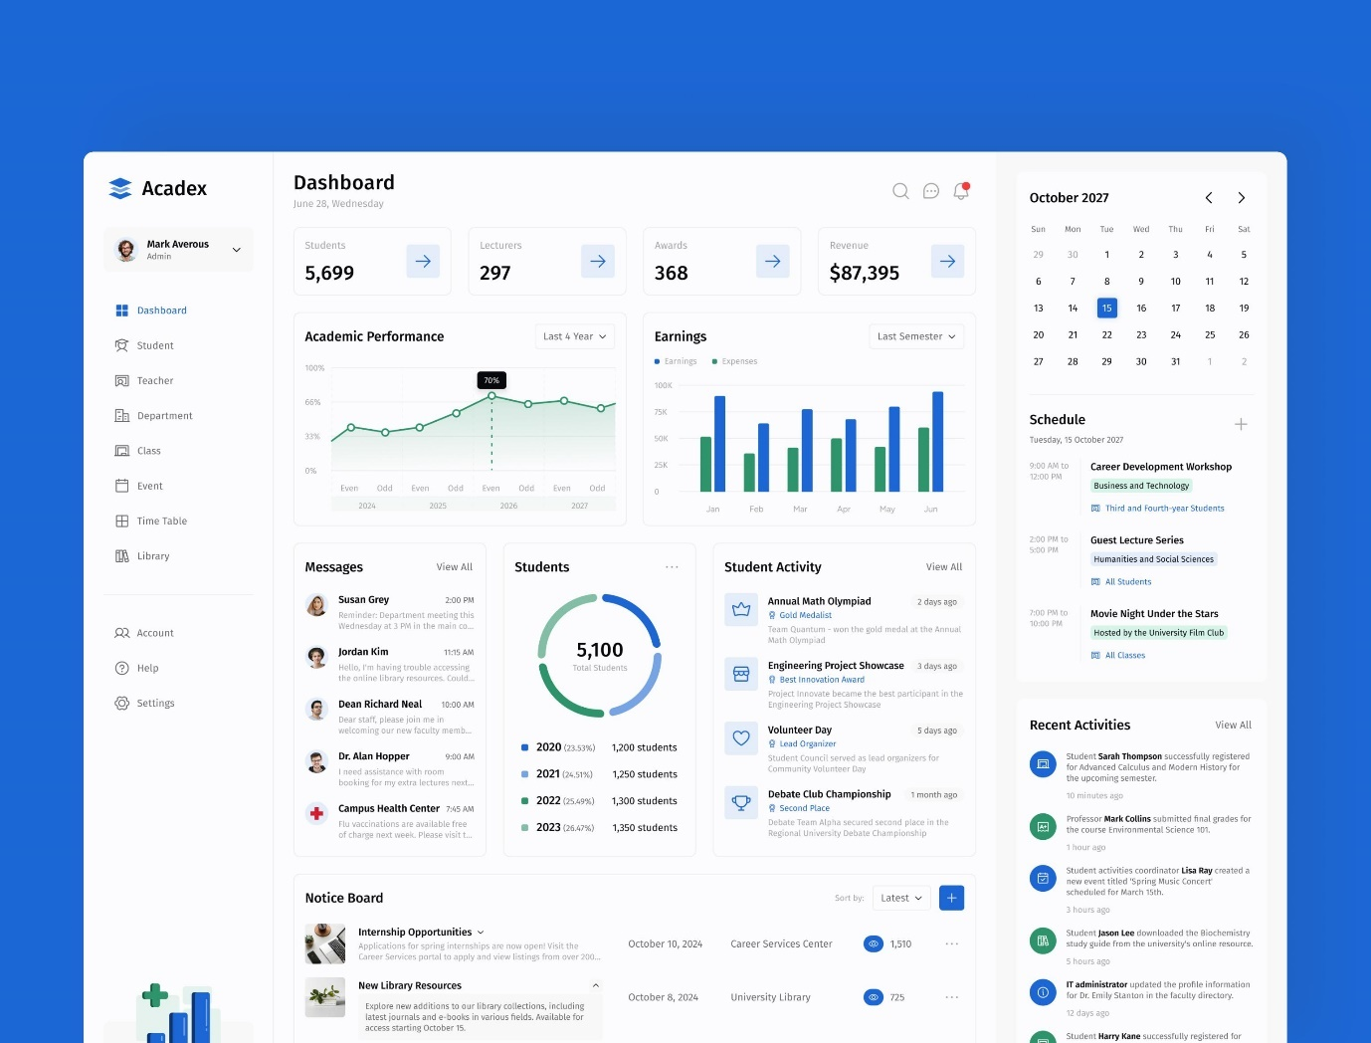
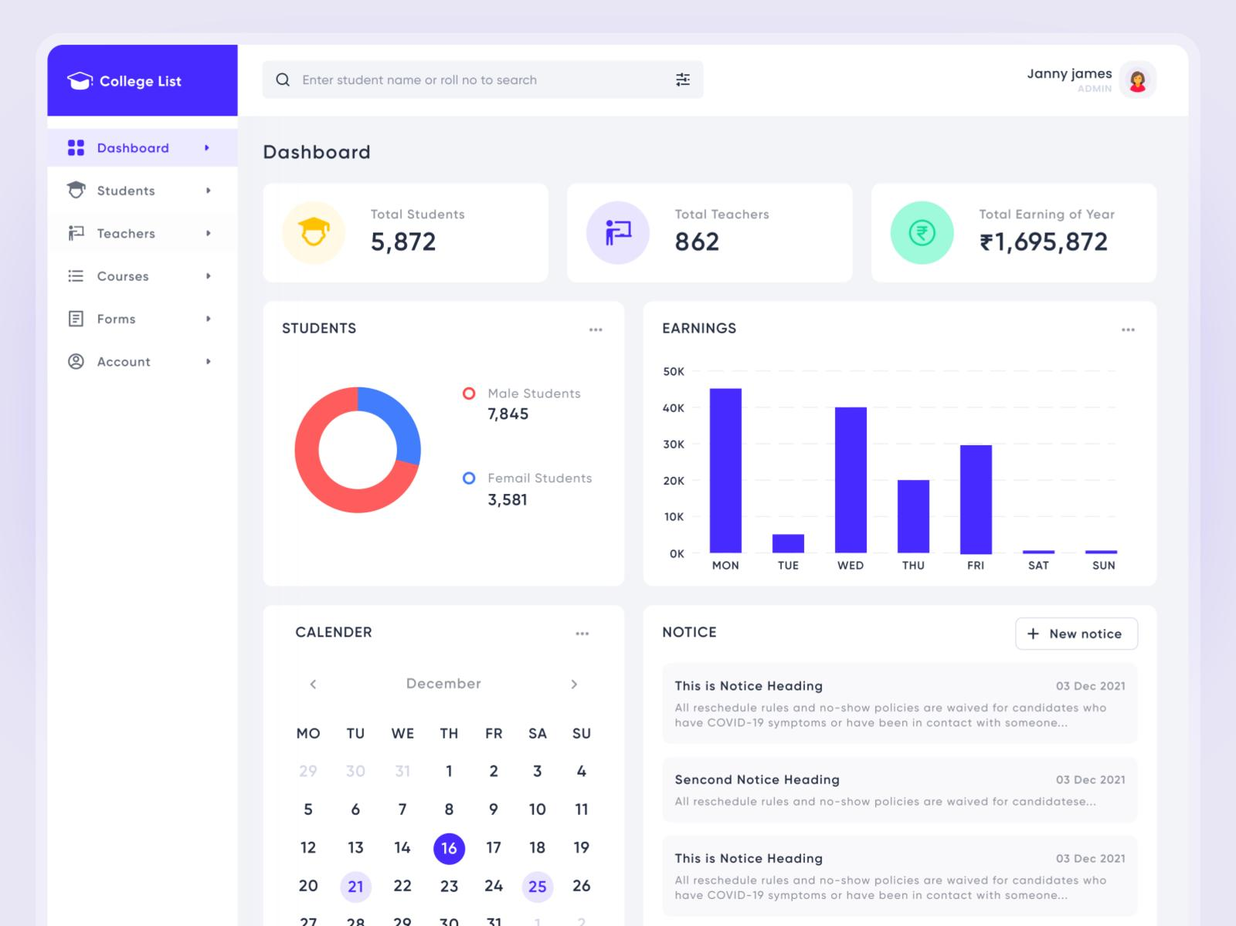
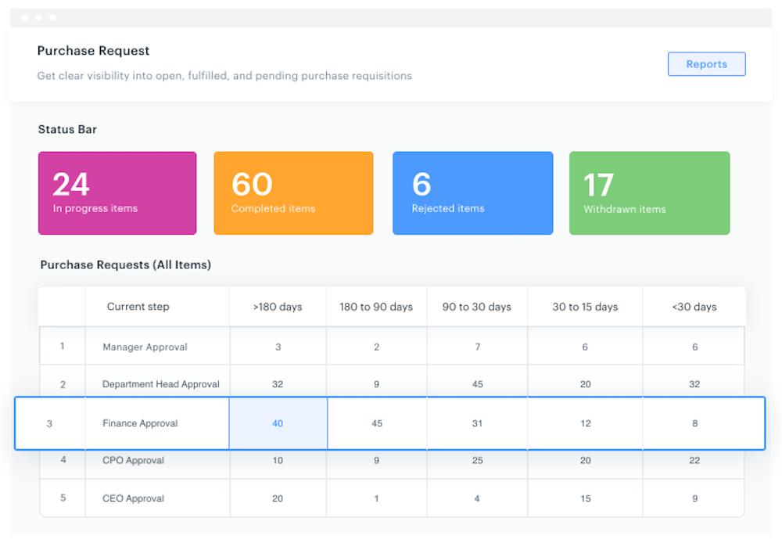
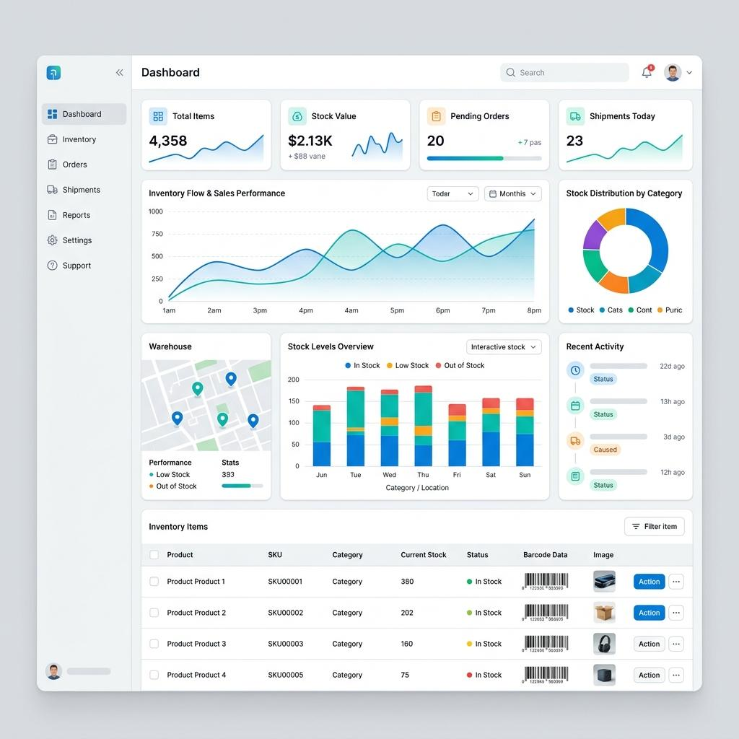
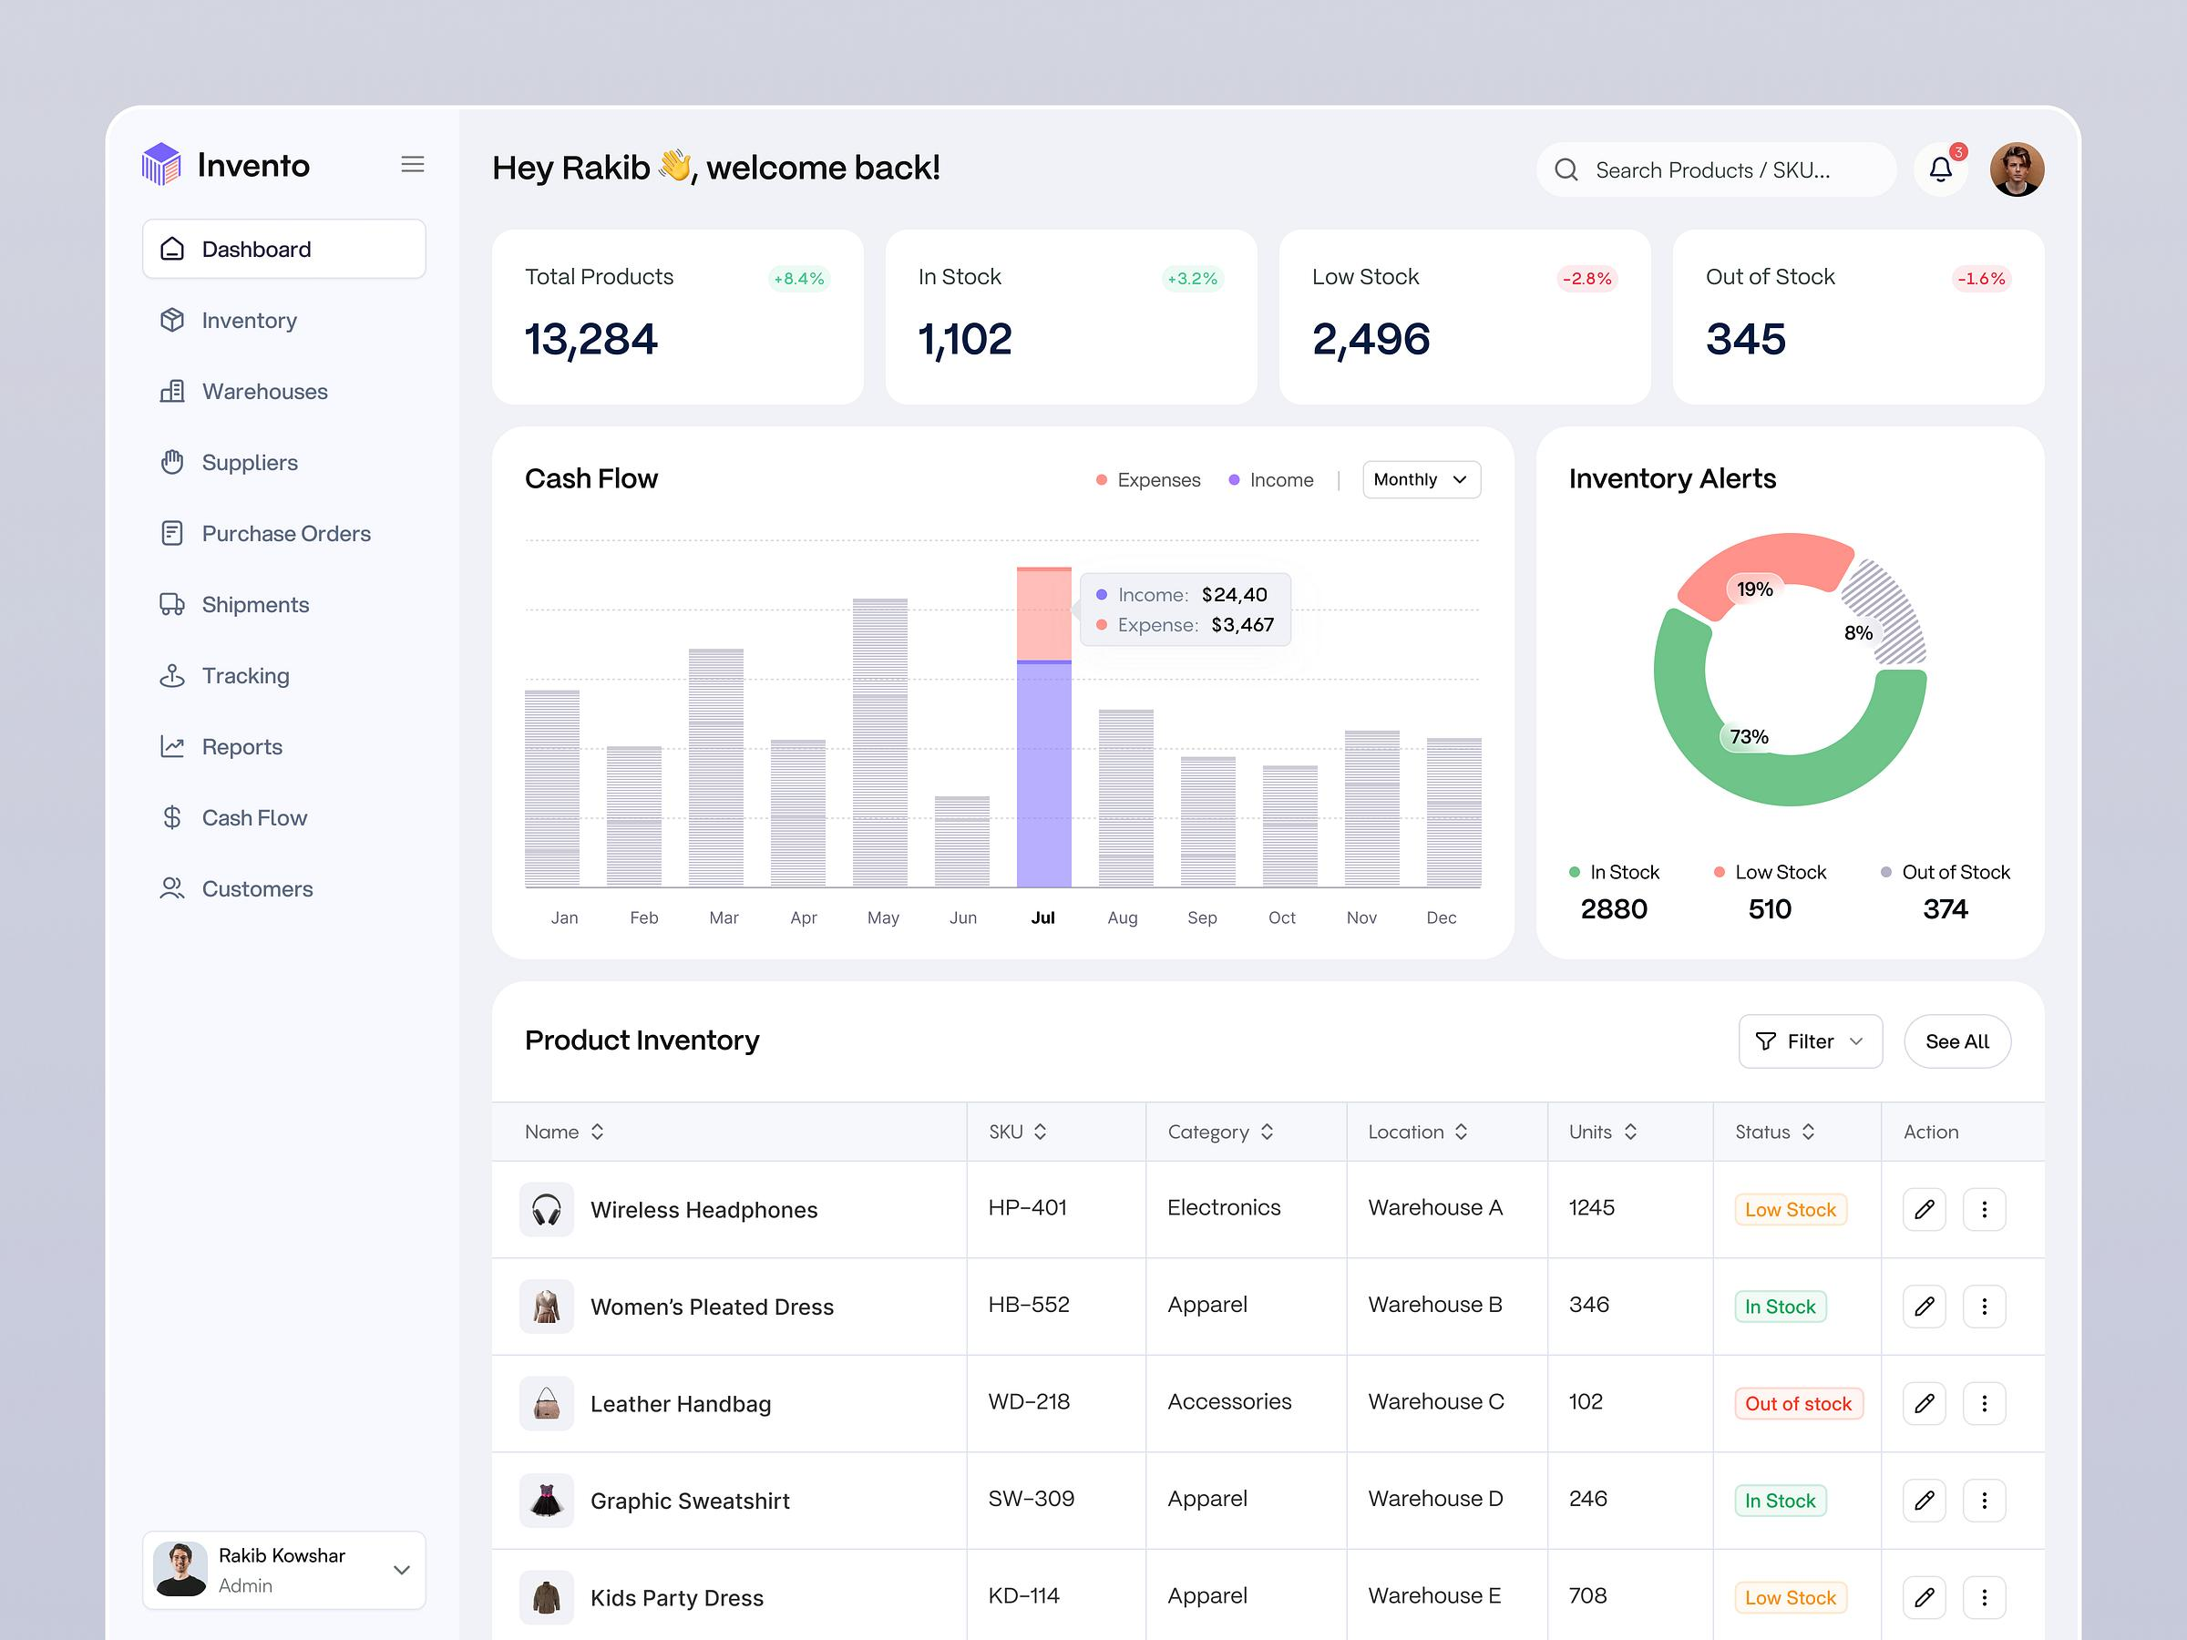

1. MAIN LOGIN PAGE
Header
[SVIT LOGO]
Sardar Vallabhbhai Patel Institute of Technology
Vasad Campus
Campus Administration Portal
Login Form
Field | Input
User ID | Email / Employee ID
Password | ********
Role | Automatically identified / optional selection
Remember Me | ☑
Login | 🔐 Login
Forgot Password | Click here
Login Roles
- Admin
- Principal
- Head
- Purchase Officer
- Maintenance Officer
- Clerk
- Lab Technician
- Authorized User
- Chairman
Main Page Buttons
After the login section, the main portal can display:
① Auditorium Request
② Maintenance Request
③ Purchase Request
④ Car Requisition
⑤ Inventory Portal
A user can see only the portal for which permission has been assigned.

2. COMMON DASHBOARD
After successful login:
Header
SVIT Logo | Sardar Vallabhbhai Patel Institute of Technology, Vasad Campus
Right side:
🔔 Notifications | 👤 User Name | Role | Logout

Dashboard Cards
For Admin
Card | Information
🏛 Auditorium | Total / Pending
🔧 Maintenance | Total / Pending
🛒 Purchase | Total / Pending
🚗 Car Requisition | Total / Pending
📦 Inventory | Total Items
👥 Users | Active Users
🏢 Departments | Total Departments
⚠ Stock | Low Stock Items
Quick Actions

  - New Auditorium Request

  - New Maintenance Request

  - New Purchase Request

  - New Car Requisition

  - Inventory Entry
- Manage Users
- Manage Departments
- Pending Approvals
Common Request Table
Request No. | Date | Department | Request Type | Requested By | Current Authority | Status
AUD-0001 | 28-08-26 | CSE | Auditorium | Faculty | Head | Pending
PUR-0021 | 28-08-26 | Mechanical | Stationery | Clerk | Purchase Officer | Pending
Status:
🟡 Pending
🟢 Approved
🔴 Rejected
🔵 In Process
⚫ Completed

3. PORTAL 1 — AUDITORIUM REQUEST
User Page
New Auditorium Request
Fields:
- Request Number — Auto
- Department
- Faculty / Employee Name
- Email
- Mobile
- Event Name
- Event Type
- Date
- Start Time
- End Time
- Expected Participants
- Auditorium
- Required Facilities
  - Projector
  - Sound System
  - AC
  - Microphone
  - Stage
  - Seating
  - Other
- Special Requirement
- Attachment
- Submit
Auditorium Master
Admin:
Manage Auditoriums
Auditorium | Capacity | Location | Facilities | Status | Edit
Aero Auditorium | 250 | 2nd Floor | Projector, Sound | Active | Edit
EDC Hall | 150 | 1st Floor | Projector | Active | Edit
Buttons:
+ Add Auditorium
Edit | Delete | Active/Inactive

Auditorium Approval Desk
Requests in Your Lane
Only requests assigned to the logged-in authority should appear.
Request | Department | Date | Time | Applicant | Status | Action
AUD-001 | CSE | 05-09-26 | 10-1 | Mr. ABC | Pending | View
Approval Screen
- Request Details
- Previous Approvals
- Comments
- Approve
- Reject
- Send Back
- Forward
- Digital approval/signature

4. PORTAL 2 — MAINTENANCE
New Maintenance Request
Request Form
- Request No.
- Department
- Location / Building
- Floor
- Room No.
- Requester
- Category
  - Electrical
  - Plumbing
  - Civil
  - AC
  - Furniture
  - Computer/IT
  - Other
- Problem Description
- Priority
  - Normal
  - Urgent
  - Emergency
- Photo/Attachment
- Required Date
- Submit

Maintenance Approval Desk
Requests in Your Lane
The system automatically fetches:
Manage Departments & Heads → Department → Head → Email
No need to enter Head information repeatedly.
Maintenance Workflow
Employee
↓
Department Head
↓
Maintenance Officer
↓
Maintenance Clerk / Technician
↓
Work Completed
↓
Requester Confirmation
↓
Close Request
Maintenance Status
- New
- Head Approval Pending
- Maintenance Pending
- Assigned
- In Progress
- Completed
- Verified
- Closed
- Rejected

5. PORTAL 3 — PURCHASE
Purchase should have three independent sections:
A. Stationery
B. Local Purchase
C. Cleaning Items

5A. STATIONERY
Stationery Request
Item | Required Qty | Available Stock | Issue Qty
A4 Paper | 10 | 50 | 10
Pen | 100 | 250 | 100
Important Rule
Available Stock information is visible only to:
- Admin
- Purchase Officer
- Stock Clerk
Other users should see only the request information.

Stationery Master
Excel Upload
Admin/Purchase Officer can:
- Download Excel Template
- Upload Excel
- Validate Excel
- Import Items
- Update Items
- Export Excel
Example:
Item Code | Item Name | Category | Unit | Minimum Stock | Opening Stock
STA001 | A4 Paper | Stationery | Ream | 10 | 100
STA002 | Ball Pen | Stationery | Box | 5 | 50

Stationery Approval
Department Clerk
↓
Department Head
↓
Purchase Officer
↓
Stock Clerk
↓
Issue Material
↓
Stock Automatically Deducted
Example:
Previous Stock = 100
Issued = 20
New Stock = 80
The system should automatically create a stock transaction.

PDF
After approval:
Generate PDF
PDF should contain:
- SVIT Logo
- Institute Name
- Request No.
- Date
- Department
- Requested By
- Items
- Quantity
- Approval history
- Approval/signature boxes
Signature section:
Requested By | Department Head | Principal/Purchase Authority

5B. LOCAL PURCHASE
New Local Purchase
Select:
Department
Then:
- Purchase Request No.
- Date
- Department
- Requested By
- Item
- Description
- Quantity
- Estimated Rate
- Estimated Amount
- Vendor, if known
- Quotation attachment
- Justification
- Remarks
Automatic Calculation
Quantity × Rate = Amount
Subtotal + Other Charges = Total

LOCAL PURCHASE APPROVAL ENGINE
This should be dynamic.
Admin can configure:
Example
Up to ₹10,000
Department Head → Purchase Officer
Above ₹10,000
Department Head → Principal → Chairman
The amount threshold should not be hard-coded.
Admin can change:
₹10,000 → ₹25,000
without changing the application code.

Local Purchase Approval Diagram
Example:
REQUESTER
↓
DEPARTMENT HEAD
↓
PURCHASE OFFICER
↓
PRINCIPAL
↓
CHAIRMAN
↓
APPROVED
Only required authorities should appear.
If Chairman approval is not required:
REQUESTER
↓
HEAD
↓
PURCHASE OFFICER
↓
APPROVED

5C. CLEANING ITEMS
Same basic structure as Stationery.
Features
- Cleaning Item Master
- Excel Upload
- Excel Download
- Stock Management
- Department Request
- Quantity
- Previous Stock
- Issue Quantity
- Automatic Stock Deduction
- Approval
- PDF
- Email Notification
Cleaning Item Example
Code | Item | Unit | Minimum Stock | Current Stock
CL001 | Floor Cleaner | Bottle | 10 | 25
CL002 | Phenyl | Litre | 20 | 50
CL003 | Broom | Nos. | 10 | 35

6. PORTAL 4 — CAR REQUISITION
New Car Requisition
Fields:
- Requisition No.
- Department
- Requester
- Date
- Required Date
- Reporting Time
- Return Time
- Destination
- Purpose
- Number of Persons
- Vehicle Type
- Driver Required
- Special Instructions
- Attachment
Approval Role
Admin should be able to configure:
- Head
- Admin Officer
- Principal
- None
- Other Authority
Workflow
CAR REQUEST
↓
DEPARTMENT HEAD
↓
ADMIN OFFICER
↓
PRINCIPAL
↓
CAR/DRIVER ASSIGNMENT
↓
TRIP COMPLETED
↓
CLOSE

Car Request Dashboard
Req. No. | Department | Date | Destination | Persons | Status
CAR001 | Civil | 02-09-26 | Ahmedabad | 8 | Approved
Admin can assign:
- Vehicle
- Driver
- Departure Time
- Return Time

7. PORTAL 5 — INVENTORY
This will be a more comprehensive asset/inventory module.
Inventory User Roles
Admin can assign:
- Clerk
- Lab Technician
- Head
- Principal
- Chairman
- Inventory Officer

Department Selection
First select:
Department
Then:
- Academic Year
- Inventory Year
- Category
Categories:
- Furniture
- Electrical
- Computer/IT
- Laboratory
- Other

INVENTORY DATA ENTRY
Main Table
Sr. No. | Item | Ground Floor | First Floor | Second Floor | Third Floor | Total | Remarks
1 | Table | 10 | 5 | 8 | 2 | 25 | Good
2 | Chair | 20 | 15 | 10 | 5 | 50 | Good
3 | Computer | 0 | 20 | 25 | 10 | 55 | Working
But each floor should internally store:
Office / Lab + Room + Quantity
Example:
First Floor
├── Office
│ └── 5
└── Computer Lab-1
└── 20
This will make future reporting much easier.

Inventory Actions
Each item should have:
Edit | Save | Transfer | Use/Non-use | View History
Transfer
Example:
Computer Lab – CSE
↓
Transfer
↓
Computer Lab – IT
The system records:
- From Department
- To Department
- Item
- Quantity
- Date
- Reason
- Authorized By

8. INVENTORY REPORTS
Admin should have:
Department-wise
CSE
Furniture 125
Electrical 45
Computer 85
Other 20
--------------------
Total 275
Floor-wise
- Ground Floor Total
- First Floor Total
- Second Floor Total
- Third Floor Total
Category-wise
- Furniture
- Electrical
- Computer
- Laboratory
- Other
Status-wise
- In Use
- Not in Use
- Damaged
- Under Repair
- Transferred
Reports
- PDF
- Excel
- Print
- Year-wise Report
- Department-wise Report
- Item-wise Report

9. ADMIN PANEL
This is the master control center.
Admin Dashboard
Administration Menu
Dashboard

MASTER SETTINGS
├── Institute Profile
├── Logo
├── Departments
├── Heads
├── Users
├── Roles
├── Permissions
└── Email Settings

AUDITORIUM
├── Auditoriums
├── Approval Rules
└── Requests

MAINTENANCE
├── Departments
├── Categories
├── Approval Rules
└── Requests

PURCHASE
├── Stationery
├── Local Purchase
├── Cleaning Items
├── Stock
└── Approval Rules

CAR
├── Vehicles
├── Drivers
└── Approval Rules

INVENTORY
├── Items
├── Departments
├── Transfers
└── Reports

REPORTS
├── Request Reports
├── Approval Reports
├── Purchase Reports
├── Stock Reports
└── Inventory Reports

SYSTEM
├── Email
├── Notifications
├── Audit Log
├── Backup
└── Settings

10. MANAGE DEPARTMENTS & HEADS
Department Master
Department | Code | Head | Head Email | Status | Action
Computer Engineering | CE | Dr. ABC | head@svit... | Active | Edit
Mechanical | ME | Dr. XYZ | head@svit... | Active | Edit
Admin can:
Add | Edit | Delete | Activate/Deactivate
When a department is selected anywhere in the portal, the system automatically fetches the corresponding Head.

11. USER MANAGEMENT
Add User
Fields:
- Employee ID
- Name
- Email
- Mobile
- Department
- Designation
- Role
- Username
- Password / Reset Password
- Status
Role Assignment
Example:
Mr. A
Department: Computer Engineering
Role: Clerk
Permissions:
✓ Stationery Request
✓ Cleaning Request
✓ Inventory View
✗ Stock Management
✗ Admin Panel

12. ROLE & PERMISSION SYSTEM
Instead of giving fixed permissions, use a permission matrix.
Module | Admin | Head | Clerk | Purchase | Maintenance | Principal
Auditorium | ✓ | ✓ | Request | — | — | ✓
Maintenance | ✓ | ✓ | Request | — | ✓ | ✓
Purchase | ✓ | Approve | Request | ✓ | — | ✓
Car | ✓ | Approve | Request | — | — | ✓
Inventory | ✓ | View | Entry | Stock | — | View
Users | ✓ | — | — | — | — | —
Settings | ✓ | — | — | — | — | —
Admin can modify permissions.

13. APPROVAL ENGINE
This is one of the most important parts of the system.
Instead of programming every approval workflow separately, create a common:
Approval Workflow Engine
Request
↓
Find Department
↓
Find Applicable Workflow
↓
Find Amount / Request Type
↓
Find Required Role
↓
Create Approval Task
↓
Send Notification
↓
Approver Action
↓
Next Approval
↓
Final Approval
↓
Generate PDF
↓
Complete
Approval Actions
- Approve
- Reject
- Send Back
- Forward
- Return for Correction
- Add Comment
Every action should be recorded.

14. NOTIFICATION SYSTEM
Admin setting:
Sender Email Address
Example:
admin@svitvasad.ac.in
System sends notifications for:
- New Request
- Approval Pending
- Approved
- Rejected
- Sent Back
- Purchase Approved
- Material Issued
- Maintenance Completed
- Car Approved
- Inventory Transfer
Notification
Subject:
Purchase Request PUR-0025 Awaiting Your Approval
Email contains:
- Requester
- Department
- Amount
- Request details
- Approval button
- Login button

15. DATABASE STRUCTURE
I recommend using PostgreSQL/Supabase for this system because the portal has many interconnected modules, approval workflows and audit records.
Core Tables
1. users
users
-----
id PK
employee_id
name
email
mobile
department_id FK
designation
password_hash
status
created_at
updated_at
2. roles
roles
-----
id PK
role_name
description
status
3. permissions
permissions
-----------
id PK
module
action
description
4. user_roles
user_roles
----------
id PK
user_id FK
role_id FK
5. role_permissions
role_permissions
----------------
id PK
role_id FK
permission_id FK

16. ORGANIZATION TABLES
departments
departments
-----------
id PK
department_code
department_name
head_user_id FK
head_email
status
designations
designations
------------
id PK
designation_name
status

17. AUDITORIUM TABLES
auditoriums
auditoriums
-----------
id PK
name
location
capacity
facilities
status
auditorium_requests
auditorium_requests
-------------------
id PK
request_no
department_id FK
requested_by FK
event_name
event_type
request_date
start_time
end_time
auditorium_id FK
participants
description
status
created_at

18. MAINTENANCE TABLES
maintenance_requests
maintenance_requests
--------------------
id PK
request_no
department_id FK
requested_by FK
location
floor
room_no
category
priority
description
attachment
status
created_at
maintenance_assignments
maintenance_assignments
-----------------------
id PK
request_id FK
assigned_to FK
assigned_date
completion_date
remarks
status

19. PURCHASE TABLES
purchase_items
purchase_items
--------------
id PK
item_code
item_name
category
unit
minimum_stock
current_stock
status
purchase_requests
purchase_requests
-----------------
id PK
request_no
request_type
department_id FK
requested_by FK
total_amount
justification
status
created_at
purchase_request_items
purchase_request_items
---------------------
id PK
request_id FK
item_id FK
quantity
rate
amount

20. STOCK TABLE
Do not rely only on current_stock.
Create a proper transaction table.
stock_transactions
stock_transactions
------------------
id PK
item_id FK
department_id FK
transaction_type
quantity
previous_stock
new_stock
reference_type
reference_id
issued_by FK
transaction_date
remarks
Transaction types:
PURCHASE
OPENING
ISSUE
RETURN
TRANSFER_IN
TRANSFER_OUT
ADJUSTMENT
DAMAGE
This provides a complete stock history.

21. LOCAL PURCHASE APPROVAL TABLE
approval_workflows
approval_workflows
------------------
id PK
module
request_type
min_amount
max_amount
status
approval_workflow_steps
approval_workflow_steps
-----------------------
id PK
workflow_id FK
step_no
role_id FK
required
Example:
Workflow | Amount | Step | Role
LP-1 | 0–10,000 | 1 | Head
LP-1 | 0–10,000 | 2 | Purchase Officer
LP-2 | 10,001+ | 1 | Head
LP-2 | 10,001+ | 2 | Purchase Officer
LP-2 | 10,001+ | 3 | Principal
LP-2 | 10,001+ | 4 | Chairman
This makes the approval process fully configurable.

22. APPROVAL TRANSACTION TABLE
approvals
approvals
---------
id PK
request_type
request_id
workflow_id FK
step_no
approver_user_id FK
approver_role_id FK
action
comments
approved_at
ip_address
Actions:
PENDING
APPROVED
REJECTED
SENT_BACK
FORWARDED

23. CAR TABLES
vehicles
vehicles
--------
id PK
vehicle_no
vehicle_type
capacity
driver_id
status
drivers
drivers
-------
id PK
name
mobile
license_no
status
car_requests
car_requests
------------
id PK
request_no
department_id FK
requested_by FK
travel_date
reporting_time
return_time
destination
purpose
persons
vehicle_id FK
driver_id FK
status

24. INVENTORY TABLES
inventory_items
inventory_items
---------------
id PK
item_code
item_name
category
department_id FK
year
status
remarks
inventory_locations
inventory_locations
-------------------
id PK
department_id FK
floor
building
room_no
location_type
location_name
inventory_assets
inventory_assets
----------------
id PK
item_id FK
location_id FK
quantity
condition
use_status
remarks
inventory_transfers
inventory_transfers
-------------------
id PK
item_id FK
from_department_id
to_department_id
from_location_id
to_location_id
quantity
transfer_date
authorized_by
remarks

25. COMMON ATTACHMENT TABLE
One common attachment system can be used instead of separate attachment fields everywhere.
attachments
attachments
-----------
id PK
module
reference_id
file_name
file_path
file_type
uploaded_by
uploaded_at
Supports:
- PDF
- JPG
- PNG
- Excel
- Word

26. NOTIFICATION TABLE
notifications
notifications
-------------
id PK
user_id FK
title
message
module
reference_id
is_read
created_at

27. AUDIT LOG
Very important for an institutional portal.
audit_logs
audit_logs
----------
id PK
user_id FK
module
action
reference_id
old_data
new_data
ip_address
created_at
This allows Admin to see:
Who changed what, when, and from which account.

28. SYSTEM SETTINGS
system_settings
system_settings
---------------
id PK
setting_key
setting_value
description
updated_by
updated_at
Examples:
INSTITUTE_NAME
INSTITUTE_LOGO
SENDER_EMAIL
PURCHASE_LIMIT
CURRENCY
TIMEZONE
EMAIL_ENABLED

29. DATABASE RELATIONSHIP
The overall relationship should look like:
┌──────────────┐
│ USERS │
└──────┬───────┘
│
┌──────▼───────┐
│ ROLES │
└──────┬───────┘
│
┌──────▼─────────┐
│ PERMISSIONS │
└────────────────┘

┌─────────────┐
│ DEPARTMENTS │
└──────┬──────┘
│
├───────────────┐
│ │
▼ ▼
AUDITORIUM MAINTENANCE
│ │
└───────┬───────┘
│
▼
APPROVAL ENGINE
│
┌───────┼────────┐
▼ ▼ ▼
PURCHASE CAR INVENTORY
│ │
▼ ▼
STOCK TRANSFER

30. ADMIN CONTROL OF ALL WORKFLOWS
The most important feature should be:
Admin → Workflow Builder
Admin can create:
Module: Local Purchase
Condition: Amount > ₹10,000
Then select:
☑ Department Head
☑ Purchase Officer
☑ Principal
☑ Chairman
Or:
Module: Car Requisition
☑ Head
☑ Admin Officer
☑ Principal
Or:
Module: Auditorium
☑ Selected Person Only
This matches your requirement that "only selected person" should see the approval request.

31. PDF DOCUMENT SYSTEM
Every major approved request should have a standardized PDF.
PDF Header
SVIT LOGO
SARDAR VALLABHBHAI PATEL INSTITUTE OF TECHNOLOGY
VASAD CAMPUS
Request Type
Request No.
Date
Body
Request details / items / amount / department.
Approval Diagram
Requested By
↓
Department Head
↓
Purchase Officer
↓
Principal
↓
Chairman
Each required person gets a separate:
Signature / Approval Box
with:
- Name
- Designation
- Date
- Digital approval status

32. RECOMMENDED TECHNICAL ARCHITECTURE
For this particular portal, I recommend:
Frontend
SvelteKit
Backend
Node.js / API
Database
PostgreSQL / Supabase
Authentication
Role-based authentication with secure password hashing.
Storage
Supabase Storage for:
- PDFs
- Excel files
- Images
- Attachments
- Logo
PDF
Server-side PDF generation.
Excel
Import/export templates for Stationery and Cleaning Items.
Email
SMTP / institutional email account.

33. FINAL MAIN MENU
The finished portal should have this structure:
SVIT CAMPUS ADMINISTRATION PORTAL
│
├── Dashboard
│
├── 1. Auditorium Request
│ ├── New Request
│ ├── My Requests
│ ├── Approval Desk
│ └── Auditoriums
│
├── 2. Maintenance
│ ├── New Request
│ ├── My Requests
│ ├── Approval Desk
│ ├── Assign Technician
│ └── Completed Requests
│
├── 3. Purchase
│ ├── Stationery
│ ├── Local Purchase
│ ├── Cleaning Items
│ ├── Stock
│ ├── Approval Desk
│ └── Reports
│
├── 4. Car Requisition
│ ├── New Request
│ ├── My Requests
│ ├── Approval Desk
│ ├── Vehicles
│ └── Drivers
│
├── 5. Inventory
│ ├── New Entry
│ ├── Inventory List
│ ├── Transfer
│ ├── Department Report
│ ├── Floor Report
│ └── Item Report
│
└── ADMIN PANEL
├── Institute Settings
├── Logo
├── Departments
├── Heads
├── Users
├── Roles
├── Permissions
├── Approval Workflows
├── Email Settings
├── Notifications
├── Audit Logs
└── System Settings
Key design decision
I would build this as one application with five modules, not five separate websites. The Admin Panel controls all five modules, while each employee sees only the functions permitted by their role.
This will also make future additions—such as Hostel, Library, Examination, Transport, HR, Leave, Complaint, or Asset Management—much easier without rebuilding the system.

